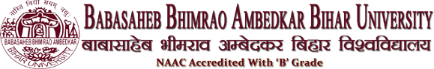
University Department of Persian
Our Selected Stake Holders
- Dr. Md Abul Kalam, Assistant professor in Persian, B.R.Amedkar Bihar University, Muzaffarpur, Bihar.
- Md. Jawaid Akhtar, Lecturer in Persian, Khwaja Moinuddin Chishti University, Lucknow.
- Sayed Imteyaz Karimi, Chairman, Bihar Public Service Commission, Patna, Bihar.
- Dr. Shahreyar, Businessman in Dubai.
- Dr. Md. Yunus Ansari, H.O.D Persian, Girls College, Madhubani.
- Dr. Md. Aftab Ziya, Superintendent Epigraphist, (Arabic and Persian Inscriptions) Archeology Department in Nagpur.
- Dr. Md. Ataur Rahman, Millat College, Darbhanga.
- Dr. Ejaz Ahmad, Director, Arabic & Persian Research Institute, Patna.
- Dr. Md. Mohsin, Department of Persian, Rampur College, Rampur (U.P).
- Md. Ilyas Ansari, Retired Govt. Teacher, C.K. Higher Secondary School(10+2). Kamtaul, Muzaffarpur.
- Prof. Syed Hassan Abbas, Former H.O.D, Department of Persian, BHU, UP.
- Shamim Ahmad Ansari, Guest Lecturer, M.S.K.B College, B.R. Ambedkar Bihar University, Muzaffarpur, Bihar.
- Imtiyaz Ahmad Ansari, Guest Lecturer, L.S College, B.R. Ambedkar Bihar University, Muzaffarpur, Bihar.

